7. Create a page translation table that meets the requirements of the virtual memory system shown below. Assume a page size of 25, with pages 0 through 7 in logical memory, and frames 0 to 17 in physical memory.

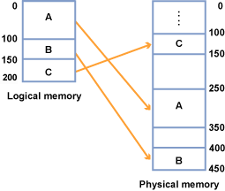

**Answer:**

|  |  |
| --- | --- |
| Page | Frame |
| 0 | 10 |
| 1 | 11 |
| 2 | 12 |
| 3 | 13 |
| 4 | 16 |
| 5 | 17 |
| 6 | 4 |
| 7 | 5 |

A is pages 0 through 3, which are stored in frames 10 through 13.

B is pages 4 and 5, which are stored in frames 16 and 17.

C is pages 6 and 7, which are stored in frames 4 and 5.

The logical memory is of size 200 and is broken up into eight pages of size 25. Thus the pages are numbered 0 (for 0 to 24), 1 (for 25 to 49), 2 (for page 50 to 74), 3 (for pages 75 to 99), and so on out to 4, 5, 6, & 7 (for 175 to 199)

 The physical memory is of size 450 and is broken up into eighteen frames of size 25. The frames are numbered 0 (for 0 to 24) out to 17 (for 425 to 449)

Page size must be equal to frame size.  Then logical Block A is stored in Physical Block A, logical Block B is stored in physical Block B, and logical Block C is stored in the larger virtual memory.  It is helpful to write in the numbers of the logical pages and physical blocks onto the diagram. For block A which is of size 100, the page numbers are 0 to 3 for logical memory locations 0 to 99; while the frame numbers are 10 to 13 for physical locations 250 to 349. The page translation table for Block A would then be:

Page    Frame

0           10

1            11

2            12

3            13